AWS LAB 1

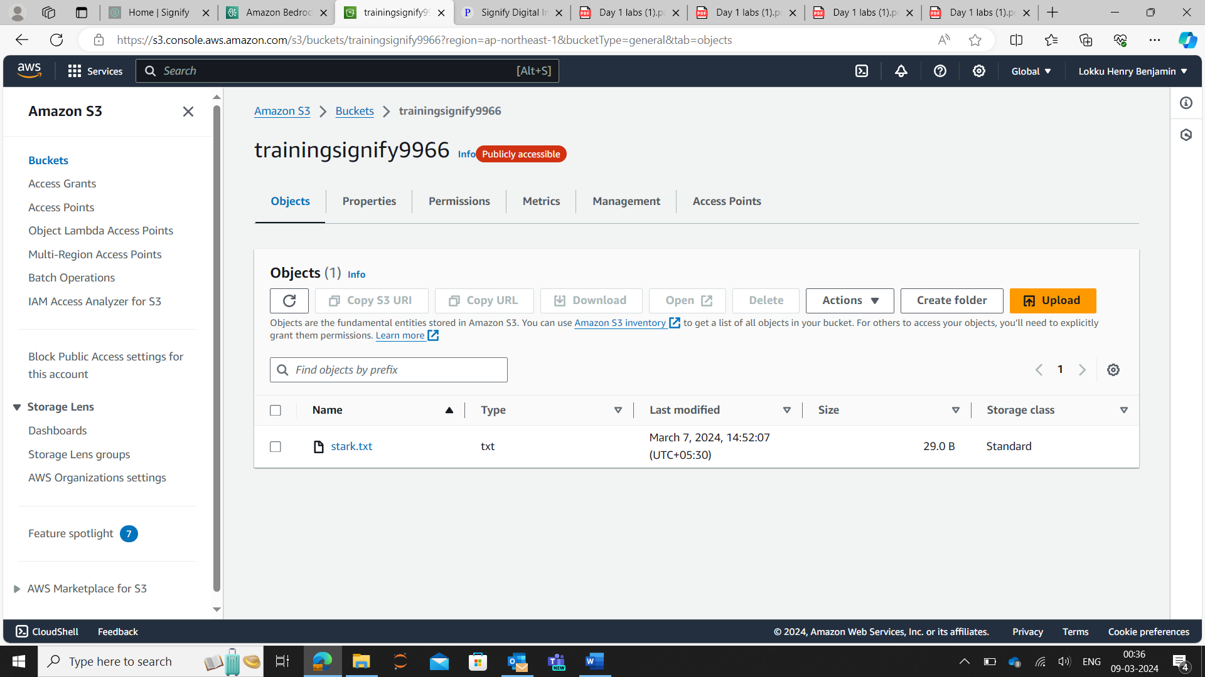

AWS LAB 3

Task -1:

Task -2:

Task -4:

AWS LAB 4

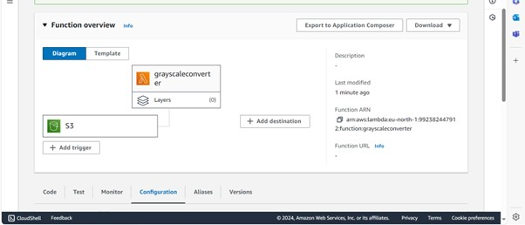

AWS Lab 5

Task-1:

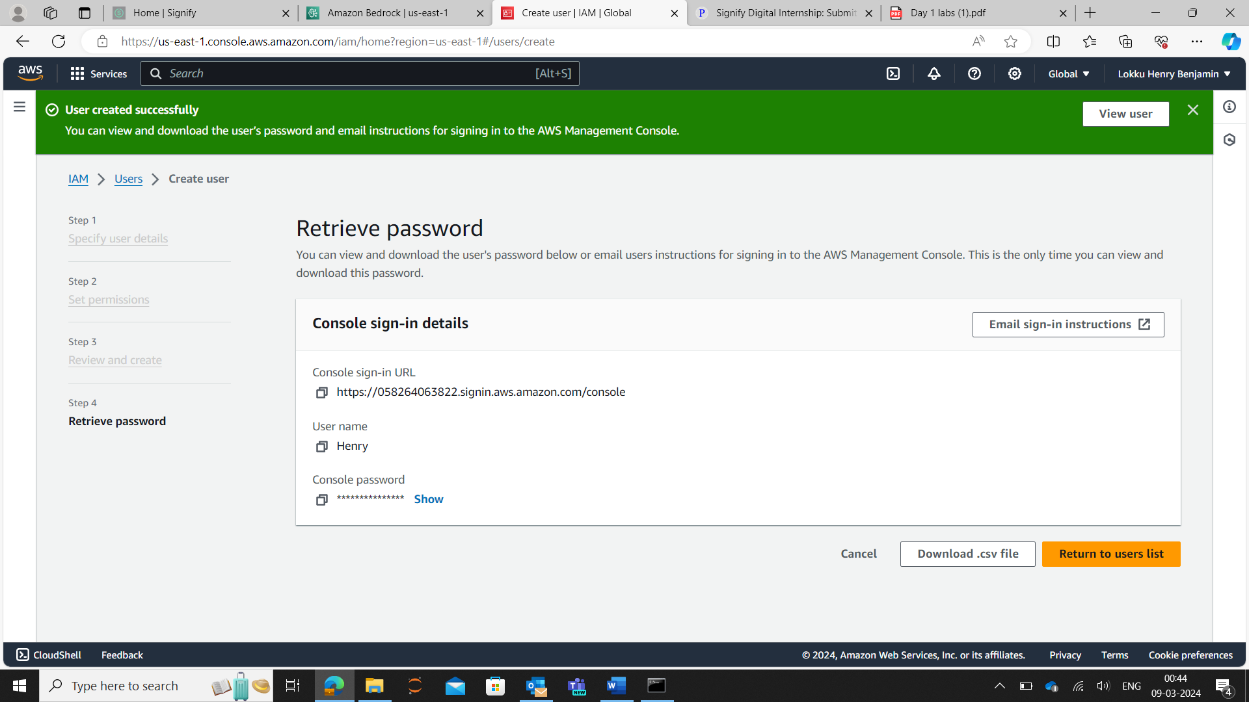

Task-2:

Task-3:

Task-4:

Task-5:

